

**TAYLOR’S UWE DUAL AWARDS PROGRAMMES**

**March 2023 SEMESTER**

|  |  |  |  |  |
| --- | --- | --- | --- | --- |
| **Student Name** | **Student ID** | **Date** | **Score** | **Remarks** |
| **Dev Mani Maharjan** | **0355610** | **5-16-2023** |  |  |
| **Total** | | |  |  |

Contents

Question no 1. 1

Code of question no 1: 1

Output of question no1: 2

Question no 2 3

Question no 2 code: 3

Output of Question no 2: 4

Question no 3: 5

Code of question no 3: 5

# Question no 1.

Write a C program to reverse a word using a stack concept.

## Code of question no 1:

#include <stdio.h>

int top = -1;

char stacks [3];

void push (char number){

if (top==2){

    printf("%c cannot be inserted into a stack as stack is full.\n",number);

}

else{

top++;

stacks [top] = number;

printf ("%c is inserted into stack.\n",number);

}

}

char pop (){

    if (top==-1){

        printf("Stack is empty.\n");

    }

    else{

        char r_number=stacks[top];

    top--;

    printf ("%c",r_number);

    }

}

int main(int argc, char const *argv[])

{

push('D');

push('A');

push('D');

push('D');

    printf ("Its reverse form is(Pop operation): \n");

pop();

pop();

pop();

    return 0;

}

## Output of question no1:

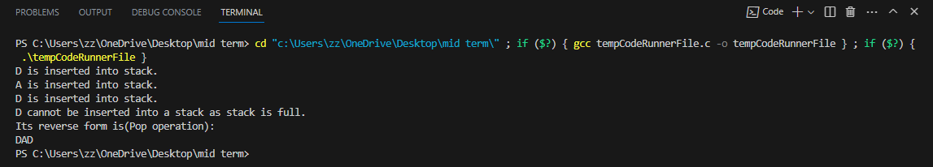

# Question no 2

Write a C program to mimic Bank Counter which gives a ticket number like 1 2 and 3 using a queue concept.

## Question no 2 code:

#include<stdio.h>

char *queues[3];

int rear = -1;

int front = -1;

void enqueue(char element[]){

    if (rear==2){

        printf("%s cannot be inserted into the queue. The queue is full.\n",element);

    }else{

        rear++;

        queues[rear] = element;

        printf("%s \n",queues[rear]);

    }

}

void dequeue(){

    if(front == rear){

        printf("Dequeue operation cannot be performed because queue is empty.");

    }

    else{

        front++;

        printf("%s is displayed on the screen. \n",queues[front]);

    }

}

int main(int argc, char const *argv[])

{

    printf("Nabil Bank bank counter queue \n");

    enqueue("Ticket No 1");

    enqueue("Ticket No 2");

    enqueue("Ticket No 3");

    printf("-----------------------\n");

    printf("Dequeue operation.....\n");

    dequeue();

    dequeue();

    dequeue();

    dequeue();

    return 0;

}

## Output of Question no 2:

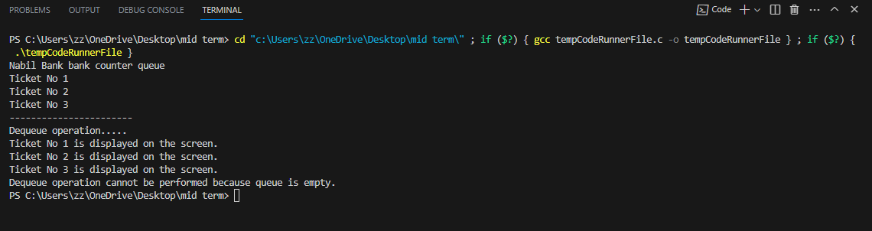

# Question no 3:

Write a C program to implement a singly linked list. Perform the following operations on it.

1. Insertion (insert an element in the end of the linked list)
2. Deletion (Delete an element from the beginning of the linked list)
3. Traversing (Visit each element in the linked list at least once and print the element of each node)

## Code of question no 3:

#include <stdio.h>

#include <stdlib.h>

#include <string.h>

typedef struct Node

{

    char data[50];

    struct Node *nextNode;

}

node;

node *firstNode;

node *newNode;

void insertfromlast(char data[])

{

    newNode = malloc(sizeof(node));

    strcpy(newNode->data, data);

    newNode->nextNode = NULL;

    if (firstNode == NULL)

    {

        firstNode = newNode;

    }

    else{

        node *uNode = firstNode;

        while (uNode->nextNode != NULL)

        {

            uNode = uNode->nextNode;

        }

            uNode->nextNode = newNode;

    }

    printf("%s\n", newNode->data);

}

void traverse(){

    node *node = firstNode;

    while (node->nextNode != NULL)

    {

        printf("%s =>", node->data);

        node = node->nextNode;

    }

    printf("%s\n", node->data);

}

void removeFromLast(){

    if (firstNode == NULL)

    {

        printf("List is empty\n");

        return;

    }

    node *nodetodelete = firstNode;

    firstNode = firstNode->nextNode;

    nodetodelete->nextNode = NULL;

}

int main(int argc, char const *argv[]){

    printf("Insertion Operation in the linkedlist.....\n");

    insertfromlast("Wash Face");

    insertfromlast("Drink Coffee");

    insertfromlast("Code");

    printf("Traversing operation in the linkedlist....\n");

    traverse();

    printf("Deletion operation from the linkedlist....\n");

    removeFromLast();

    traverse();

    return 0;

}

Output Of Question no 3:

